**Github Migration Procedures (Local)**

**Disclaimer:** The repository will be created on a local machine running Windows 10 or later due to an incompatibility issue with the Windows version on the remote machine. The process of creating the GitHub runner will be covered in a separate document: *GitHub Migration Procedures – Remote Machine.docx*.

**For older windows, must have:**

* Visual C++ Redistributable Packages
  + [**https://www.microsoft.com/en-au/download/details.aspx?id=48145**](https://www.microsoft.com/en-au/download/details.aspx?id=48145&fbclid=IwZXh0bgNhZW0CMTAAAR23fy31USRD0v4FMxVD3lXvmSs3j9lyZw5NzymJ7XLqS-Q30JWcrhZRIqc_aem_wmflCYCR26xuecLbRWtLSQ)
* Powershell for windows 7
  + [**https://github.com/PowerShell/PowerShell/tree/0883438e5524efd8558a29cdbbd2bd63bebe9484?tab=readme-ov-file**](https://github.com/PowerShell/PowerShell/tree/0883438e5524efd8558a29cdbbd2bd63bebe9484?tab=readme-ov-file&fbclid=IwZXh0bgNhZW0CMTAAAR1xJR1R9gN2x1vtSGX3kVhBw9hyPyM2q5eOPeetJ_GYguyp4UswOw2Y-M8_aem_mbj07mRNJztMW6h6iCWWdw)
* Git (old version)
  + <https://github.com/git-for-windows/git/releases/download/v2.16.2.windows.1/Git-2.16.2-64-bit.exe>
* Download .NET Framework 4.6.2 Runtime
  + <https://dotnet.microsoft.com/en-us/download/dotnet-framework/net462>

**First Step (Creating Repository on kplusitdev)**

* Navigate to: <https://github.com/kplusitdev>
* Click the green "New" button or go directly to GitHub New Repository.
* 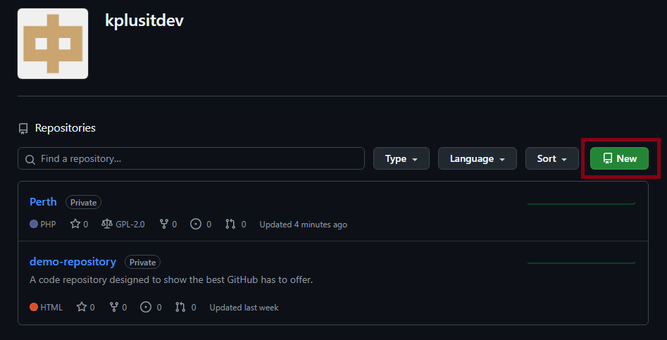
* Provide a repository name (e.g., my-project).
* Optionally, add a description.
* Choose repository visibility (Public or Private).
* (Optional) Initialize with a README.md, .gitignore, or a license.
* Click Create repository.

**Second Step (Upload the project to the repository)**

**Prerequisites**

* Install [Git](https://git-scm.com/) on your computer. (for old windows version the link is provided in the first page)
* Open a terminal or command prompt.
* Navigate to your project folder.

**Steps to Upload an Existing Project**

* Initialize Git in the Project Folder:
  + cd path/to/your-project
  + git init
  + 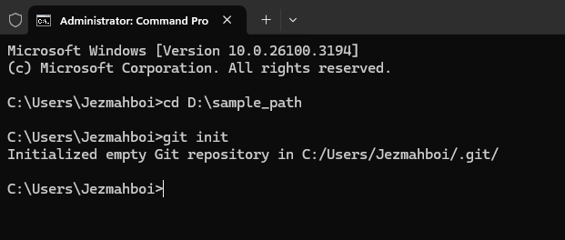
* Add Remote Repository:
  + Copy the repository URL from GitHub.
  + 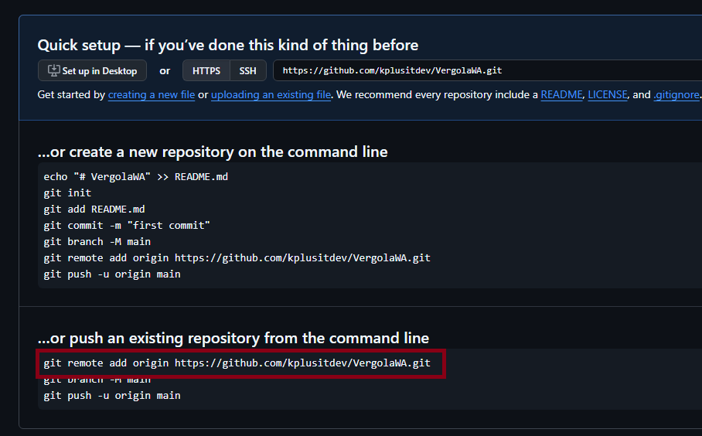
  + Run the following command to add the remote origin:
  + git remote add origin (your repository url)
  + Example: git remote add origin https://github.com/kplusitdev/VergolaWA.git
* Add and Commit Files:
  + git add .
  + git commit -m "Initial commit"
* Push to GitHub:
  + git branch -M main
  + git push -u origin main.
* Create a New Branch
  + In the dropdown, type the name of your new branch in the search box.
  + Click "Create branch: [branch name]" from "main" (or your current branch)
  + 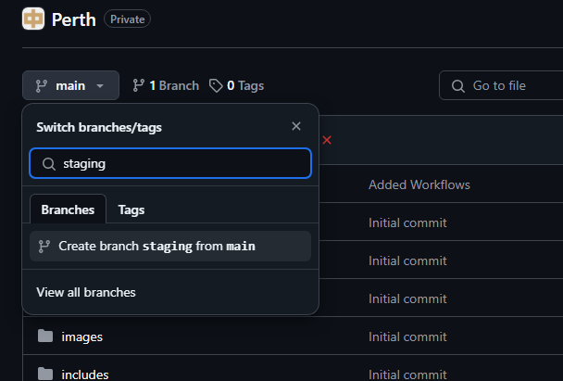

**Files Needed to Modified**

**Path: C:\xampp\apache\conf\extra\httpd-ssl.conf**

* **Add**

<!-- new entry under "Listen 443" -->

Listen vglwa.knowledgeplus.net.au:6000

<!-- add new entry at the bottom -->

#--------------------------------

# Added host for perth on port 6000

#--------------------------------

<VirtualHost _default_:6000>

DocumentRoot "C:/xampp/htdocs/VergolaVictoria_as_live"

ServerName vglwa.knowledgeplus.net.au:6000

ServerAlias www.vglwa.knowledgeplus.net.au:6000

# DirectoryIndex index.php

# # SetEnv APPLICATION_ENV "development"

<Directory "C:/xampp/htdocs/VergolaVictoria_as_live">

DirectoryIndex index.php

AllowOverride All

Order allow,deny

Allow from all

Require all granted

</Directory>

</VirtualHost>

* **Replace**

<!-- DocumentRoot "C:/xampp/htdocs" -->

ServerName www.vglwa.knowledgeplus.net.au:6000

<!-- ServerName www.example.com:443 -->

ServerAlias [www.vglwa.knowledgeplus.net.au](http://www.vglwa.knowledgeplus.net.au)

**Path: C:\xampp\apache\conf\extra\httpd-vhosts.conf**

* **Add**

<!-- add new entry at the bottom -->

#--------------------------------

#Added host for perth on port 6000

#--------------------------------

<VirtualHost *:6000>

# <VirtualHost 1.121.198.72:6000>

DocumentRoot "C:/xampp/htdocs/VergolaVictoria_as_live"

ServerName vglwa.knowledgeplus.net.au:6000

ServerAlias www.vglwa.knowledgeplus.net.au:6000

# DirectoryIndex index.php

SetEnv APPLICATION_ENV "development"

<Directory "C:/xampp/htdocs/VergolaVictoria_as_live">

DirectoryIndex index.php

AllowOverride All

Order allow,deny

Allow from all

Require all granted

</Directory>

</VirtualHost>

* **Replace**

<!-- replace all strings of "Require local" with "Require all granted" -->

<IfModule alias_module>

Alias /licenses "C:/xampp/licenses/"

<Directory "C:/xampp/licenses">

Options +Indexes

<IfModule autoindex_color_module>

DirectoryIndexTextColor "#000000"

DirectoryIndexBGColor "#f8e8a0"

DirectoryIndexLinkColor "#bb3902"

DirectoryIndexVLinkColor "#bb3902"

DirectoryIndexALinkColor "#bb3902"

</IfModule>

Require all granted

ErrorDocument 403 /error/XAMPP_FORBIDDEN.html.var

</Directory>

Alias /phpmyadmin "C:/xampp/phpMyAdmin/"

<Directory "C:/xampp/phpMyAdmin">

AllowOverride AuthConfig

Require all granted

ErrorDocument 403 /error/XAMPP_FORBIDDEN.html.var

</Directory>

Alias /webalizer "C:/xampp/webalizer/"

<Directory "C:/xampp/webalizer">

<IfModule php5_module>

<Files "webalizer.php">

php_admin_flag safe_mode off

</Files>

</IfModule>

AllowOverride AuthConfig

Require all granted

ErrorDocument 403 /error/XAMPP_FORBIDDEN.html.var

</Directory>

</IfModule>

<LocationMatch "^/(?i:(?:xampp|security|licenses|phpmyadmin|webalizer|server-status|server-info))">

# Require local

Require all granted

ErrorDocument 403 /error/XAMPP_FORBIDDEN.html.var

</LocationMatch>

**Database Related**

* Verify if the database will be renamed to match new site location, must be devided before executing the script
* List of tables to be cleared
  + ver_chronoforms_data_builder_vic
  + ver_chronoforms_data_builderpersonal_vic
  + ver_chronoforms_data_clientpersonal_vic
  + ver_chronoforms_data_colour_vic
  + ver_chronoforms_data_contract_bom_meterial_vic
  + ver_chronoforms_data_contract_bom_vic
  + ver_chronoforms_data_contract_details_vic
  + ver_chronoforms_data_contract_items_default_deminsions
  + ver_chronoforms_data_contract_items_deminsions
  + ver_chronoforms_data_contract_items_vic
  + ver_chronoforms_data_contract_list_vic
  + ver_chronoforms_data_contract_statutory_vic
  + ver_chronoforms_data_contract_vergola_vic
  + ver_chronoforms_data_drawings_vic
  + ver_chronoforms_data_followup_vic
  + ver_chronoforms_data_image_vic
  + ver_chronoforms_data_installer_vic
  + ver_chronoforms_data_lead_vic
  + ver_chronoforms_data_letters_vic
  + ver_chronoforms_data_marketing_category_vic
  + ver_chronoforms_data_material_default_supplier_vic
  + ver_chronoforms_data_material_supplier_vic
  + ver_chronoforms_data_measurement_vic
  + ver_chronoforms_data_notes_vic
  + ver_chronoforms_data_pics_vic
  + ver_chronoforms_data_quote_vic
  + ver_chronoforms_data_section_vic
  + ver_chronoforms_data_special_condition_vic
  + ver_chronoforms_data_suburbs_vic
  + ver_chronoforms_data_supplier_vic
  + ver_chronoforms_data_travel_vic
  + ver_contact_details
* List of tables to be populated
  + ver_chronoforms_data_suburbs_vic